**UFCFR5-15-3 Advanced Topics In Web Development II**

**Workshop (Completing the PHP Vehicle Example)**

TASKS IN CLASS

1. Finish any previous workshops that are still unfinished.

2. Finish coding the LandVehicle/Motorized/NonMotorized classes if you haven't already done so.

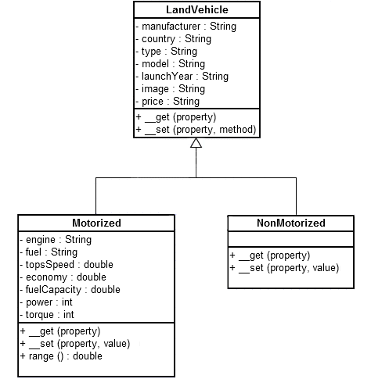

3. Finish coding the HTML output as specified in the last worksheet. Your output should look something like the following pages:

[http://www.cems.uwe.ac.uk/~p-chatterjee/php/vehicle.php?model=Evora+S](http://www.cems.uwe.ac.uk/%7Ep-chatterjee/php/vehicle.php?model=Evora+S)

[http://www.cems.uwe.ac.uk/~p-chatterjee/php/vehicle.php?model=Route+29](http://www.cems.uwe.ac.uk/%7Ep-chatterjee/php/vehicle.php?model=Route+29)

4. Create a table in MySQL to store details of vehicles mapping an entity such as the following:

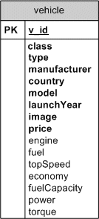

(Note the new attribute class (motorized, nonMotorized); the bolded attributes (NOT NULL) required for all vehicles and the others (NULL allowed) which are not applicable to NonMotorized vehicles.)

5. Create a new version of the script to pull the data from a MySQL table to instantiate the required objects and display as HTML when using the URL's as given in 2 above.

EXTRA TASKS FOR HOME

1. Try to normalise the table above to hold the data in a more optimized relational form. Hence you might need to create separate country, manufacturer, vehicleType and vehicle tables. Note the mismatch between the objects and the data held in the database. An example of the 'object / relation impedance mismatch' discussed in a forthcoming lecture.

2. Create a new version of the script to pull the data from these tables and use it to instantiate new vehicle objects.